**1 程序代码**

#include<iostream>

using namespace std;

class Coordinate

{ // 定义Coordinate类

public:

Coordinate()

{

times = 2;

cout << "Coordinate construction1 called!" << endl;

}

// 设置默认的输入坐标数目

~Coordinate()

{

cout << "Coordinate destruction called!" << endl;

}

// 析构函数

void InputCoord()

{

for (int i = 0; i < times; i++)

{

cout << "Please Input x:" << endl;

cin >> Coord[i][1];

cout << "Please Input y:" << endl;

cin >> Coord[i][2];

}

}

// 输入坐标}

void ShowCoord()

{

cout << "The coord is:" << endl;

for (int i = 0; i < times; i++)

{

cout << "(" << Coord[i][1] << "," << Coord[i][2] << ")" << endl;

}

}

// 显示已经输入的坐标}

void ShowAvgCoord()

{

float avgx = 0;

float avgy = 0;

for (int i = 0; i < times; i++)

{

avgx = avgx + Coord[i][1];

avgy = avgy + Coord[i][2];

}

avgx = avgx / times;

avgy = avgy / times;

cout << "The AVG coord is:" << endl;

cout << "(" << avgx << "," << avgy << ")" << endl;

}

// 显示输入坐标的均值}

private:

float Coord[100][100]; // 存放输入坐标的数组

int times; // 存放输入坐标数目

};

int main()

{

Coordinate x;

x.InputCoord();

x.ShowCoord();

x.ShowAvgCoord();

return 0;

}

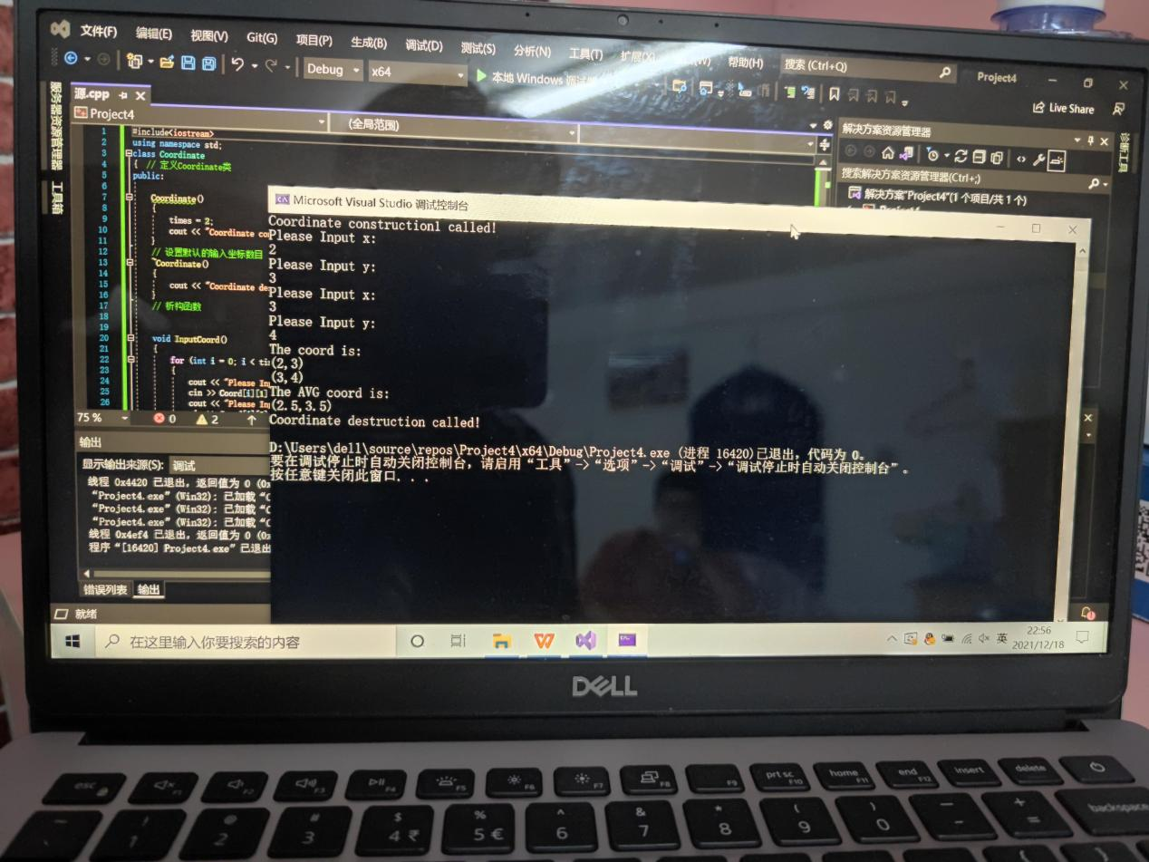

**2程序代码**

#include <iostream>

using namespace std;

class Coordinate {

public:

Coordinate()

{

times = 2;

cout << "Coordinate construction1 called!" << endl;

}

Coordinate(int times1)

{

times = times1;

cout << "Coordinate construction2 called!" << endl;

}

~Coordinate()

{

cout << "Coordinate destruction called!" << endl;

}

void InputCoord()

{

for (int i = 0; i < times; i++)

{

cout << "Please Input x:" << endl;

cin >> Coord[i][1];

cout << "Please Input y:" << endl;

cin >> Coord[i][2];

}

}

void ShowCoord()

{

cout << "The coord is:" << endl;

for (int i = 0; i < times; i++)

{

cout << "(" << Coord[i][1] << "," << Coord[i][2] << ")" << endl;

}

}

void ShowAvgCoord()

{

float avgx = 0;

float avgy = 0;

for (int i = 0; i < times; i++)

{

avgx = avgx + Coord[i][1];

avgy = avgy + Coord[i][2];

}

avgx = avgx / times;

avgy = avgy / times;

cout << "The AVG coord is:" << endl;

cout << "(" << avgx << "," << avgy << ")" << endl;

}

private:

float Coord[100][100]; // 存放输入坐标的数组

int times; // 存放输入坐标数目

};

int main()

{

Coordinate x;

x.InputCoord();

x.ShowCoord();

x.ShowAvgCoord();

Coordinate y(5);

y.InputCoord();

y.ShowCoord();

y.ShowAvgCoord();

return 0;

}

**运行结果**

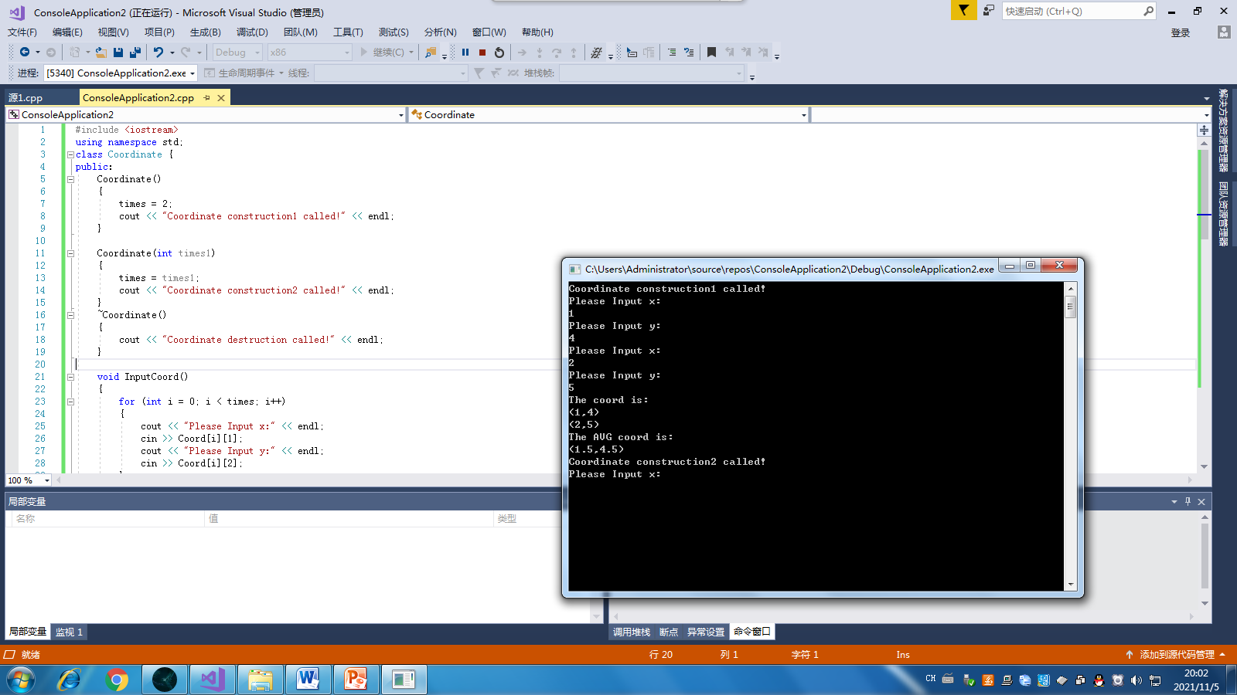

**感想与心得**

本次上机实验有两项内容，先是老师让我们自己编译代码，看编译结果，感受构造函数和析构函数的运行顺序；加深理解构造函数的作用是来创建对象时初始化对象，用来释放资源。这个来看和C语言变化较大，老师留了个小作业，让自己建一个score来实现一个功能，从这开始我感受到了C++相比C语言的优势突出了，看代码，条理层次分明，自己有时候代码程序错误，C++报错准确。建造一个类有难度，自由度高。步骤很多，一次性不好掌握。但是这是C++学习的很重要的一种编程，多加练习和实践。